Car Parking
Frequently Asked Questions
11/05/2023
How do I pay for car parking?
- Arrive in the car park and find a space (Cameras at the road entrance will have recorded your registration number.)
- Remember or make a note of your registration number as you will need it later.
- Attend your appointment or visit
- To pay by cash, when you are ready to leave, go to one of the pay stations which are situated in the Public Car Parks
- To pay by card When you are ready to leave, go to one of the pay stations or kiosks* which are situated in the Public Car Parks, Main Reception, and opposite the entrance to Springs Restaurant.
- To pay by App: (The location code is 2759)
For iPhone
https://apps.apple.com/gb/app/apcoa-connect/id535179789
For Android https://play.google.com/store/apps/details?id=com.apcoaconnect&hl=en&gl=US
- You will need to enter your full registration number for all payment types
- Return to your vehicle and leave the hospital site
*Kiosks only accept payment by card
Can I pay by cash?
Yes, but the machines do not give change. Cash is available from the ATM in M&S Café; change is available from the change machine beside the Doozy drink dispenser near the front entrance.
Can I pay by card?
Yes, card payments are accepted at all pay machines and Kiosks
Where are the kiosks located?
There is one in the main entrance to the right of the automatic doors as you look out and a second kiosk is located opposite the entrance to Springs Restaurant, on level 2.
Do you have an app I can use to pay with?
Yes, please use the APCOA App:
For iPhone https://apps.apple.com/gb/app/apcoa-connect/id535179789
For Android https://play.google.com/store/apps/details?id=com.apcoaconnect&hl=en&gl=US
The location code is 2759

Do I have to pay for parking in the car parks?
No, you can pay your car parking charges at one of our two digital kiosks located in the main entrance and opposite the entrance to Springs Restaurant (on level 2). These kiosks only accept card payment not cash.
What is the parking charge and has it gone up?
The car parking charges have not increased, but we have made changes, we have introduced a 1-hour parking charge, so you could pay less.
- Up to 30 minutes FREE*
- 31 minutes - 1 hour £2.00
- Up to 2 hours £2.70
- Up to 4 hours £4.50
- Up to 6 hours £6.50
- Up to 24 hours £8.00
- Motorcycles are exempt from car parking charges.
- Drivers who have validated their Blue Badge, are exempt from car parking charges, please see below regarding validation
- No change is given from the parking machines

*To receive 30 mins free parking, when returning to your vehicle, please visit a pay machine or kiosk and enter your vehicle registration number. If you are advised that no payment is required – your free parking period has been accepted, you will receive a grace period to leave the car park.

Car Parking is FREE for all drivers, between 22:00hrs and 06:00hrs.
What if the car park payment machine I am at is out of order?
You can pay at any machine, or by App.
Alternatively, APCOA LatePay is a post-pay option for any customer, registered or not, who is unable or fails to pay on the day they park. Drivers can pay online up to 24 hours later and thus avoid enforcement action. Visit https://www.apcoa.co.uk/ for more details.
What if I am only dropping off or picking up, is there a free period?
Yes, the first 30 minutes of parking is free.
To receive 30 mins free parking, when returning to your vehicle, please visit a pay machine or kiosk and enter your vehicle registration number. If you are advised that no payment is required – your free parking period has been accepted, you will receive a grace period to leave the car park.
What if I can’t find anywhere to park?
The first 30 minutes on the hospital site is free, after this time you will be required to pay for your time on site. We work hard to protect the space reserved for patient and visitor parking, spaces will be available in one of our many patient and visitor car parks.
What if I have an electric vehicle?
We have fourteen, 7 kw electric vehicle charging points available in car park 7, located adjacent to the Duke of Cornwall Spinal Unit.
What 3 words - speak.heads.shop
The EV charging points are on the BP Pulse network https://www.bppulse.co.uk and are visible on ‘Zap Map’ https://www.zap-map.com
Vehicle charging fees do not include the cost of parking, parking charges still apply when using these EV charging points.
I have a Blue disabled badge what do I do?
You can either take your badge to a location that has a Blue Badge Validation device (see map on the pop up banners or in the carparks) or you can register on the APCOA Blue badge portal (requires you to set up an account with APCOA) - https://bluebadge.apcoa.co.uk
The page will look like this -
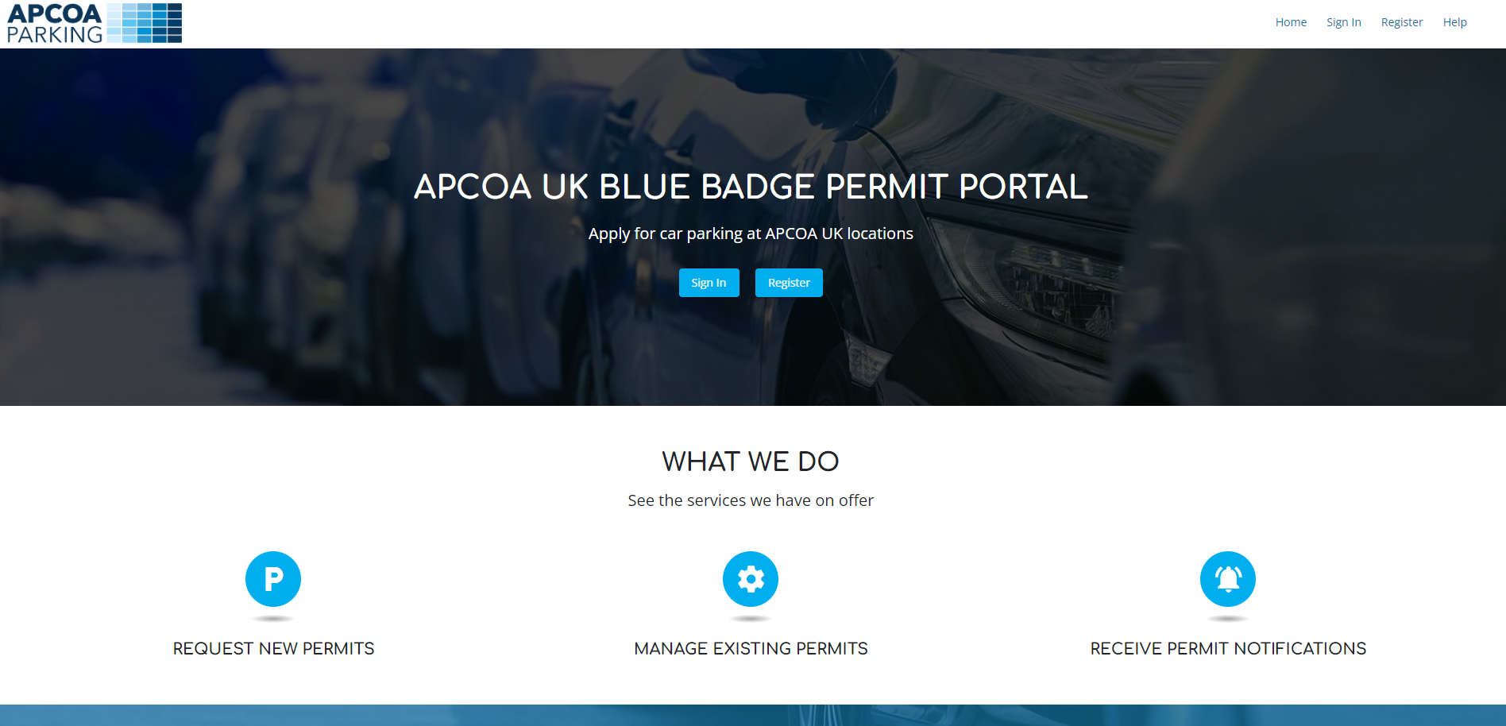
What happens if I do not validate my Blue Badge?
You will be need to pay for your parking at one of the car park payment machines or via the app, if you do not pay for your parking or register / validate your blue badge, you will receive a parking charge notice.
Can I get help with parking costs?
If you are receiving one of the following you may qualify for Discounted Parking:
- Patient receiving Universal Credit
- Patient receiving Disabled Person’s Tax Credit.
- Patient who are holders of HC2 or HC3 Certificate from NHS Low Income Scheme.
- Patient is a child, and parents are in receipt of one of the above allowances.
- Income Support
- Guaranteed Pension Credit
- NHS Tax Credit including Child Tax Credit
- War Pensions if treating a war injury
- Income based Job seekers allowance
- ESA income Based
In addition to the above, patients may qualify for a Discounted Season Ticket if attending:
- A Genito-Medical Outpatients appointment more than 15 miles from their home.
- An Artificial Limb Centre for pensionable disability.
- Any two or more appointments in one week.
Visitors may apply for a Discounted Season Ticket if they are:
- Visitors of long-stay or critically ill patients
- Visitors of an ‘out of area’ patient and are staying locally or on site to enable repeat visits.
- As a visitor, play an active role in the recuperation / rehabilitation of a patient prior to and post discharge.
- At the special request of Sister/Charge Nurse of the relevant ward.
Patients or Visitors applying for Season Tickets need to complete a “Patients’ Parking Season Ticket Request Form” which should then be taken to either the Cashier’s Office, Facilities HQ or the Enquiries Desk (Main Reception), where the discounted payment can be made.
These forms are available in the Out-Patient Clinics; Wards; Customer Care; and Facilities Directorate.
Once completed please take your form to either, the Enquiries Desk in the Main Entrance, the Cashiers Office in SDH Central of Facilities HQ in SDH South
Opening times for season tickets are;
Enquiries Desk Mon – Fri 09:00hrs – 13:30hrs What 3 words - hoot.rental.candy (Main Reception)
Cashiers Office Mon – Fri 09:00hrs – 12:00hrs What 3 words - fall.trains.live
Facilities HQ Mon – Fri 09:00hrs – 16:00hrs What 3 words - after.solid.cone
I am a link driver; do I have to pay for parking?
Link Drivers can validate their parking when supporting patient travel at a location that has a Blue Badge Validation device (see map, on the pop-up banners or in the carparks) please take your identification with you.
I am a volunteer driver for another organisation (i.e., Blood Transfusion); do I have to pay for parking?
‘Other’ volunteer drivers can validate their parking when supporting the hospital at a location that has a Blue Badge Validation device (see map, on the pop-up banners or in the carparks) please take your identification with you.
Can I have free parking?
The first 30 mins on the hospital site is free for all drivers and free for all drivers between 22:00hrs and 06:00hrs.
If you are a holder of a valid Blue Badge please take your badge to a location that has a Blue Badge Validation device (see map, on the pop up banners or in the carparks) or you can register on the APCOA Blue badge portal (requires you to set up an account with APCOA) - https://bluebadge.apcoa.co.uk the webpage looks like this -
Oncology patients - attending hospital for oncology treatment, to receive FREE parking, please speak to your department to have your parking validated.
Renal patients - attending the hospital for renal treatment, to receive FREE parking, please speak to your department to have your parking validated.
End of Life Care - If you are attending the hospital for end-of-life care of a patient, you will be given a ‘butterfly pass’ which the Enquiries hatch in the main entrance will use to give you FREE parking.
Parents of sick children staying overnight - The parent of a child in hospital overnight is a parent or guardian of a child or young person, under 18 years of age, who is admitted as an inpatient at hospital overnight. They receive free parking between the hours of 7.30pm and 8.00am while visiting the child. This would apply to a maximum of 2 vehicles. Please register your vehicle’s registration number. Please see the map for where you can register your vehicle.
Frequent outpatient attenders - Parking will be provided free to all outpatients who attend hospital for an appointment at least 3 times within a month and for an overall period of at least 3 months. A ‘month’ is defined as a period of 30 days. Please see the map for where you can register your vehicle.
Why was the car parking system changed from the old pay and display/pay on foot?
Most of our car park payment machines were broken and required replacement, moving to an Automatic Number Plate Recognition (ANPR) system enables us to apply car park charges fairly and provides drivers with increased payment options, including App and online payments.
With the use of ANPR cameras have you considered Data Protection issues?
A Data Protection Impact Assessment has been completed with the hospitals Information Governance Team
Do visitors have to enter their time of arrival?
In the event of a ‘mis read or failed read’ i.e. if the Vehicle Registration Number (VRN) is dirty then the car park payment machine will ask for a VRN and entry time.
What happens to the income generated from Car Park Charges?
After the running and maintenance costs, all remaining funds are used by the Trust, in the provision patient care at Salisbury District Hospital.
Have you outsourced car parking to a private company, who are APCOA?
No, the hospital car park service is managed by the hospital, the hospital sets the parking terms and conditions and tariff rates. After the running and maintenance costs, all remaining funds are used by the Trust in the provision of patient care at Salisbury District Hospital. APCOA are an experienced parking company that have been chosen following a procurement led tender, to support us in the management of our car parks. APCOA manage the operating system, servicing, and maintenance of equipment, for an agreed charge.
What should I do if I forget to pay for my parking?
Don’t worry, APCOA LatePay is a post-pay option for any customer, registered or not, who fails to pay on the day they park. Drivers can pay online up to 24 hours later and thus avoid enforcement action. Visit https://www.apcoa.co.uk/ for more details.

