**Car Parking**

**Frequently Asked Questions**

*V8 - 07/01/2025*

**How do I pay for car parking?**

1. Arrive in the car park and find a space to park.

Car Park 8 is the main visitor and patient car park with other smaller car parks dotted around the hospital site.

Cameras at Entrance A and B will have recorded your registration number.

1. Remember or make a note of your registration number as you will need it later to make payment.
2. Attend your appointment or visit.
3. **To pay by cash**. When you are ready to leave, go to one of the pay stations which are situated in the Public Car Parks
4. **To pay by card**. When you are ready to leave, go to one of the pay stations which are in the Public Car Parks, or our card only (digital) pay stations* which are in the Main Entrance area on Level 3 and outside the Springs Entrance on Level 2
5. **To pay by App: (**The location code is 2759)

For iPhone

<https://apps.apple.com/gb/app/apcoa-connect/id535179789>

For Android <https://play.google.com/store/apps/details?id=com.apcoaconnect&hl=en&gl=US>

1. You will need to enter your full registration number for all payment types.
2. Return to your vehicle and leave the hospital site.

*Card only (digital) pay stations only accept payment by bank card

**Can I pay by cash?**

Yes, but the pay station machines do not give change or accept notes.

Cash is available from the ATM located in M&S Café at the Main Entrance Level 3.

Change is available from the change machine beside the Doozy drink dispenser located under the stairs at the Main Entrance Level 3.

Please note the digital pay stations **do not** accept cash payments.

**The two types of pay stations in use on the hospital site:**

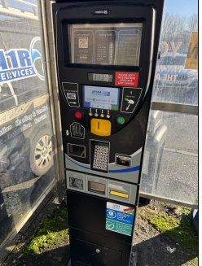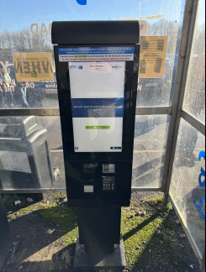

Card and cash pay station‘Digital’ Pay station – Card ONLY

**Can I pay by card?**

Yes, card payments are accepted at all pay stations.

**Do you have an app I can use to pay with?**

Yes, please use the APCOA App:

For iPhone <https://apps.apple.com/gb/app/apcoa-connect/id535179789>

For Android <https://play.google.com/store/apps/details?id=com.apcoaconnect&hl=en&gl=US>

The location code is 2759

**Do I have to pay for parking in the car parks?**

No, you can pay your car parking charges at one of our pay stations located in the Main Entrance at Level 3 and outside the Springs Entrance on level 2. These pay stations ONLY accept card payment, they DO NOT accept cash.

**What is the parking charge and has it gone up?**

The car parking charges have not increased, however, we have made changes by introducing a 1-hour parking charge, so you could pay less:

* Up to 30 minutes FREE*
* 31 minutes - 1 hour £2.00
* Up to 2 hours £2.70
* Up to 4 hours £4.50
* Up to 6 hours £6.50
* Up to 24 hours £8.00
* Motorcycles are exempt from car parking charges.
* **Blue badge holders - blue badge holders MUST display their Blue Badge clearly on the dashboard of the vehicle and park in one of the designated Blue Badge bays located around the site, as shown on the map below.**

**If no Blue Badge bays are available, you are permitted to park in Car Park 8 (main visitor and patient car park) free of charge**.

**Please note that Blue Badges are only valid in Blue Badge bays or Car Park 8.**

**If you park outside of these designated areas, standard parking charges will apply, and payment will need to be made.**

* **No change is given at the parking pay stations.**

*To receive 30 mins free parking, when returning to your vehicle, please visit a pay station and enter your vehicle registration number. If you are advised that no payment is required and your free parking period has been accepted, you will receive a grace period to leave the car park.

Car Parking is FREE for all drivers, between 22:00hrs and 06:00hrs.

**What if the pay station I am at is out of order?**

You can pay at any other pay station or by the App.

**What if I am only dropping off or picking up, is there a free period?**

Yes, the first 30 minutes of parking is free.

To receive 30 mins free parking, when returning to your vehicle, please visit a pay station and enter your vehicle registration number. If you are advised that no payment is required and your free parking period has been accepted, you will receive a grace period to leave the car park.

**What if I can’t find anywhere to park?**

The first 30 minutes on the hospital site is free, after this time you will be required to pay for your time on site. We work hard to protect the space reserved for patient and visitor parking, spaces will be available in one of our many patient and visitor car parks.

**What if I have an electric vehicle?**

We have fourteen, 7 kw electric vehicle charging points available in car park 7 which is located adjacent to the Duke of Cornwall Spinal Unit.

What 3 words - speak.heads.shop

The EV charging points are on the BP Pulse network <https://www.bppulse.co.uk> and are visible on ‘Zap Map’ [https://www.zap-map.com](https://www.zap-map.com/)

Vehicle charging fees do not include the cost of parking, parking charges will still apply when using these EV charging points.

**I have a Blue disabled badge what do I do?**

You MUST display your Blue Badge clearly on the dashboard of your vehicle and park in one of the designated Blue Badge bays located around the site, as shown on the map below.

If no Blue Badge bays are available, you are permitted to park in Car Park 8 (main visitor and patient car park) free of charge.

Please note that Blue Badges are only valid in Blue Badge bays or Car Park 8.

**If you park outside of these designated areas, standard parking charges will apply, and payment will need to be made, failing to do so will result in a PCN being issued automatically via ANPR.**

Link to website map [siteillustrationwebsite.pdf](https://www.salisbury.nhs.uk/media/b2dmrop1/siteillustrationwebsite.pdf)

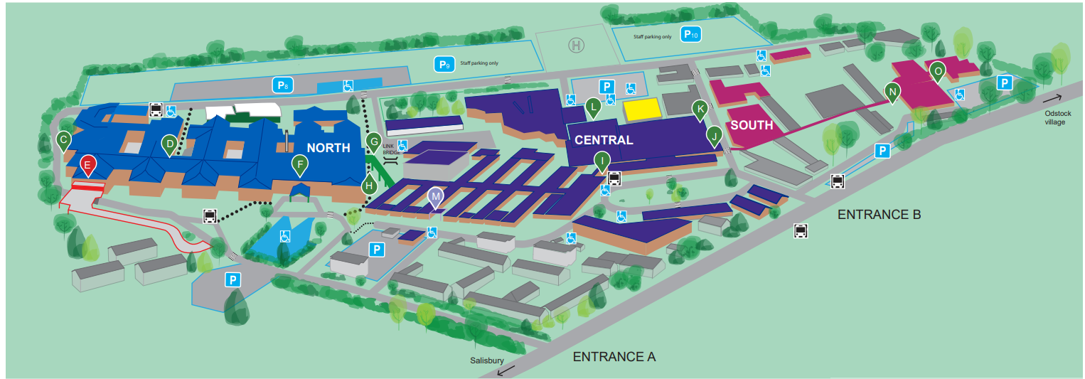

**Can I get help with parking costs?**

If you are receiving one of the following you may qualify for Discounted Parking:

* Patient receiving Universal Credit
* Patient receiving Disabled Person’s Tax Credit.
* Patient who are holders of HC2 or HC3 Certificate from NHS Low Income Scheme.
* Patient is a child, and parents are in receipt of one of the above allowances.
* Income Support
* Guaranteed Pension Credit
* NHS Tax Credit including Child Tax Credit
* War Pensions if treating a war injury.
* Income based Job seekers allowance.
* ESA income Based.

In addition to the above, patients may qualify for a Discounted Season Ticket if attending:

* A Genito-Medical Outpatients appointment more than 15 miles from their home.
* An Artificial Limb Centre for pensionable disability.
* Any two or more appointments in one week.

Visitors may apply for a Discounted Season Ticket if they are:

* Visitors of long-stay or critically ill patients
* Visitors of an ‘out of area’ patient and are staying locally or on site to enable repeat visits.
* As a visitor, play an active role in the recuperation / rehabilitation of a patient prior to and post discharge.
* At the special request of Sister/Charge Nurse of the relevant ward.

Patients or Visitors applying for Season Tickets need to complete a “Patients’ Parking Season Ticket Request Form” which should then be taken to either the Cashier’s Office, Facilities HQ, or to Switchboard Main Entrance Level 3, where the discounted payment can be made.

These forms are available in the Out-Patient Clinics; Wards; PALS and Facilities Directorate.

Once completed please take your form to either, Switchboard in the Main Entrance Level 3, the Cashiers Office in SDH Central or Facilities HQ in SDH South

Opening times for season tickets are:

Switchboard Main Entrance Level 3 Mon – Fri (Ex BH) 09:00hrs – 13:30hrs

 What 3 words - hoot.rental.candy

Cashiers Office Mon – Fri (Ex BH) 09:00hrs – 12:00hrs

What 3 words - fall.trains.live

Facilities HQ Mon – Fri (Ex BH) 09:00hrs – 12:00hrs

What 3 words - after.solid.cone

**I am a link driver; do I have to pay for parking?**

Link Drivers can validate their parking when supporting patient travel at Switchboard Main Entrance Level 3 or by having your organisation email the Security & Parking Manager, [Simon.Rigler@NHS.NET](mailto:Simon.Rigler@NHS.NET).

Please take your identification with you.

**I am a volunteer driver for another organisation (i.e., Blood Transfusion); do I have to pay for parking?**

‘Other’ volunteer drivers can validate their parking when supporting patient travel at Switchboard Main Entrance Level 3 or by having your organisation email the Security & Parking Manager [Simon.Rigler@NHS.NET](mailto:Simon.Rigler@NHS.NET)

Please take your identification with you.

**Can I have free parking?**

The first 30 minutes on the hospital site is free for all drivers and parking is free for all drivers between 22:00hrs and 06:00hrs.

**Oncology patients** - attending hospital for oncology treatment: to receive FREE parking, please speak to the department you are attending or to Switchboard Main Entrance Level 3 to have your parking validated.

**Parents of sick children staying overnight** - The parent of a child in hospital overnight is a parent or guardian of a child or young person, under 18 years of age, who is admitted as an inpatient at hospital overnight. They receive free parking between the hours of 7.30pm and 8.00am while visiting the child. This would apply to a maximum of 2 vehicles. Please register your vehicle’s registration number either with the ward or with Switchboard Main Entrance Level 3 upon arrival.

**Frequent outpatient attenders (for example Renal patients)** Parking will be provided free to all outpatients who attend hospital for an appointment at least 3 times within a month and for an overall period of at least 3 months. A ‘month’ is defined as a period of 30 days. Please speak to the outpatient department you are attending for this type of exemption.

**With the use of ANPR cameras have you considered Data Protection issues?**

A Data Protection Impact Assessment has been completed with the hospitals Information Governance Team.

**Do visitors have to enter their time of arrival?**

In the event of a ‘mis read or failed read’ i.e., if the Vehicle Registration Number (VRN) is dirty, the pay station will ask for a VRN and entry time.

**What happens to the income generated from Car Park Charges?**

After the running and maintenance costs for the car parks, all remaining funds are used by the Trust in the provision of patient care at Salisbury District Hospital.

**Have you outsourced car parking to a private company, who are APCOA?**

No. The hospital car park service is managed by the hospital and the hospital sets the parking terms and conditions and tariff rates.

After the running and maintenance costs, all remaining funds are used by the Trust in the provision of patient care at Salisbury District Hospital.

APCOA are an experienced parking company that have been chosen following a procurement led tender, to support us in the management of our car parks. APCOA manage the operating system, servicing, and maintenance of equipment, for an agreed charge.