To be added at the top of: Support Services/Available Resources (salisbury.nhs.uk)

Support available at Salisbury Foundation Trust

Please call your Cancer Support Worker on 01722 336262 (ext.2417), for full details and to sign up to any of the following support services:

Cancer Support Workers
Our Cancer Support Workers are a non-medical team here to support you and your family throughout your cancer journey - from diagnosis, treatment and beyond.
They do this by offering personalised care and support plans, to highlight any concerns you may have in order to best support you with the concerns which matter most to you.

Cancer Therapy Team
Are here to support you in managing your cancer, the symptoms related to your cancer, and it’s treatment. They can work with you to help improve your physical and mental health before (prehabilitation), during, and after (rehabilitation) your cancer treatment.
Research shows this can help improve treatment and recovery outcomes.

Protected swimming and 1:1 gym sessions
The onsite Odstock Health & Fitness Centre offer free protected time in the swimming pool and changing rooms on Fridays 2pm—3pm for cancer patients. They also offer tailored gym sessions to meet your needs.

Free Leisure Centre pass
A Wiltshire Council Leisure Centre near your home, or the Odstock Health and Fitness Centre, are offering a free 12 week pass for swimming, exercise classes or use of the gym. For more information, visit: Cancer Therapy Team - free pass Leisure Centre information (microguide.global)

Wellbeing programme
A two hour session each week, for 6 weeks covering topics including: sleep & fatigue, diet & nutrition, goal setting/pacing, aromatherapy, yoga and more.
For upcoming course dates, please visit our ‘Upcoming events at Salisbury Foundation Trust’ page

Managing Fatigue Webinar
A 45 minute skills based educational webinar to help understand and manage cancer related fatigue. The session will include what is cancer related fatigue, why it impacts every day life and six key skills to manage it’s impact.
For upcoming course dates, please visit our ‘Upcoming events at Salisbury Foundation Trust’ page

Anxiety Management Webinar
A 30 minute skills based webinar designed to help you manage any anxiety and worry you are experiencing.
For upcoming course dates, please visit our ‘Upcoming events at Salisbury Foundation Trust’ page

New button to be added to this page Information for all Cancer Patients, Families and Carers (salisbury.nhs.uk) (after the support services/available resources button)

Upcoming events at Salisbury Foundation Trust

Wellbeing programme
A two hour session each week, for 6 weeks covering topics including: sleep & fatigue, diet & nutrition, goal setting/pacing, aromatherapy, yoga and more.
Each weeks sessions are held on a Wednesday between 9:30 – 11:30am and the upcoming dates for the 6 week programme, are between:
June 5th – July 10th
September 11th – October 16th
November 6th - December 11th
Please call your Cancer Support Worker on 01722 336262 (ext.2417), to sign up to any of the above dates.

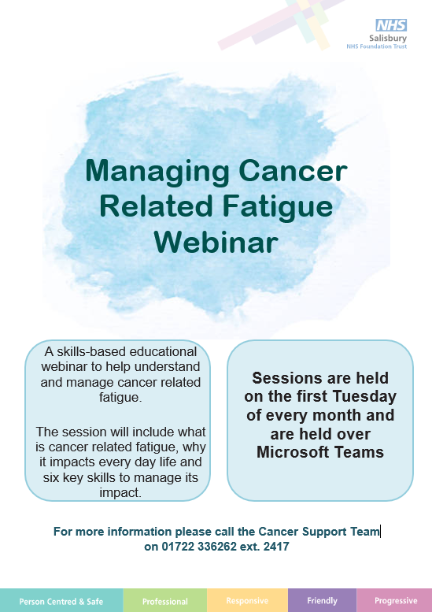
Managing Fatigue Webinar
A 45 minute skills based educational webinar to help understand and manage cancer related fatigue. The session will include what is cancer related fatigue, why it impacts every day life and six key skills to manage it’s impact.
The course is held between 10 – 10:45am on the first Tuesday of each month, so the upcoming dates for 2024 are:
Tuesday 4th June 2024
Tuesday 2nd July 2024
Tuesday 6th August 2024
Tuesday 3rd September 2024
Tuesday 1st October 2024
Tuesday 5th November 2024
Tuesday 3rd November 2024
Please call your Cancer Support Worker on 01722 336262 (ext.2417), to sign up to any of the above dates.
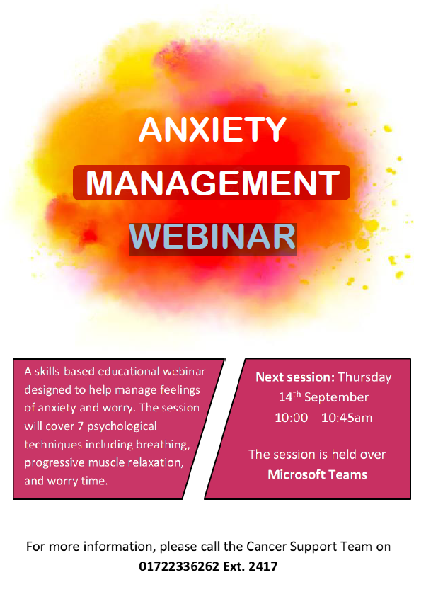
Anxiety Management Webinar
A 30 minute skills based webinar designed to help you manage any anxiety and worry you are experiencing.
The session will cover 7 psychological techniques including breathing, progressive muscle relaxation and worry time.
The upcoming dates for 2024 are:
27th June 2024
X
Please call your Cancer Support Worker on 01722 336262 (ext.2417), to sign up to any of the above dates.

